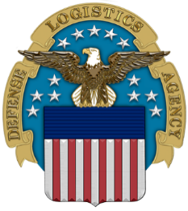
Battelle Center for Science, Engineering & Public Policy
Defense Logistics Agency
The Nation's Combat Logistics Support Agency

The Military Community Advocacy (MCA) Office Presents:
An Afternoon with the Human Resources Team from the Defense Logistics Agency (Columbus) – the Nation’s Combat Logistics Support Agency
- Learn how to apply for a position on USAJOBS.GOV
- Identify the Federal Govt job opportunities at DLA-Columbus
- Meet-and-Greet the DLA Human Resources Team
The DLA HR team will present on Thursday, 21 Sep. in Page Hall 040.
- Pick up your lunch at 11:30; lunch is provided free of charge!
- DLA Briefing Begins at 11:45
- Event ends at 1 p.m.
This is an RSVP event only with limited seats – please RSVP to
Online Survey Software | Qualtrics Survey Solutions on or before 14 Sep 2023.
If you ever wondered how to get a Federal Government job, particularly in the Columbus area, your questions will be answered.
Take the first step to your Federal Government career on Thursday, 21 September 2023 at 11:30.

Remember, seats are limited so if you are coming, please make every effort to be there on time! Thank you.

